Module01 Assignment: ASP.NET, HTML, and JavaScript

In this “hands on” activity you will learn about creating web pages that use ASP.NET, HTML, and JavaScript. This activity will take you about 3 to 6 hours, so plan accordingly!

The activity consists of the follow steps:
- Study web resources.
- Read your book
- Create your own demo.
- Write a paper.
- Submit your work to the Canvas site.

Study web resource:
Please familiarize yourself with the following topics.

1) HTML (from Home to HTML Styles)
http://www.w3schools.com/html/default.asp
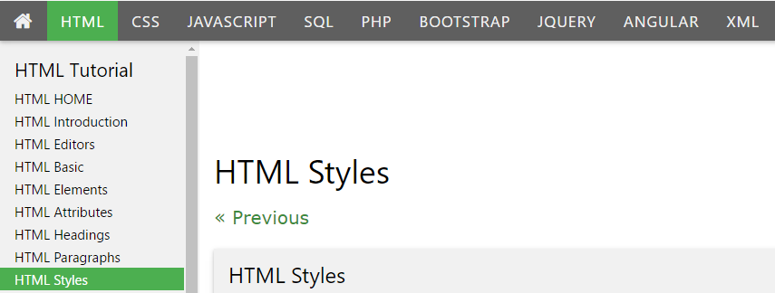

2) JavaScript (from Home to JS Objects)
http://www.w3schools.com/js/default.asp
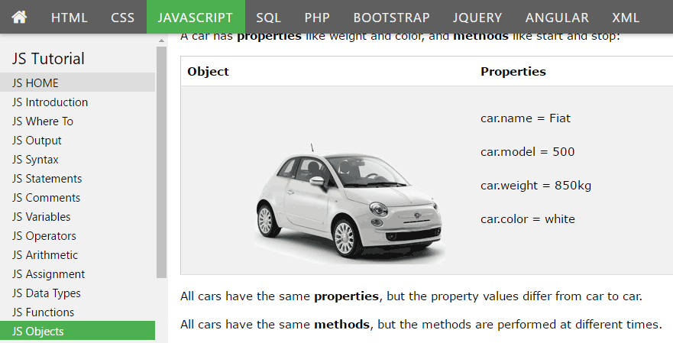

3) ASP.NET (from Home to ASP)
https://www.w3schools.com/asp/default.asp
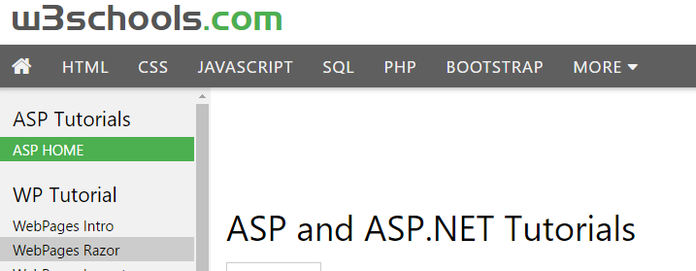

Read Your Book:
The first part of the book will be mostly review for you, but there are a number of key things to note about web development using C# within the first three chapters.

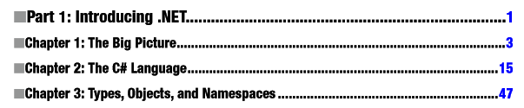

Create your own demo
Now that you have seen how others describe and demonstrate these concepts, let’s try out your skills by creating a new ASP.NET page and Word document that demonstrates how to create ASP.NET web pages that use HTML and JavaScript.

1) Create a new Empty ASP.NET project.
2) Create a web page that includes ASP.NET (C#), HTML, and JavaScript.

Write a document
Create a Word document that outlines the differences between ASP.NET, HTML, and JavaScript code. Include screen shots, please. The document should be about 2 pages in length (with the screenshots). It is alright to copy text from the internet, but this must be cited ( http://content.easybib.com/guides/citation-guides/mla-format/how-to-cite-a-website-mla/ ). Please use Microsoft Word or something compatible for your paper.

TIP: If you need help getting screenshots see this page ( http://m.wikihow.com/Take-a-Screenshot-in-Microsoft-Windows).

Important: Make sure you put it in proper, professional level, formatting! It does not have to be perfect, but if you turn in a simple blob of text, you will not get credit for it! Here is a link that may help you understand what I am looking for: https://youtu.be/9ojhSW9ljjo (External Site)

Submit your work to the Canvas site.
After you complete you your demo and paper, place the resulting files and folders into another folder, both the document and the Visual Studio Solution/Project sub-folder, and turn everything into a single zip file. Then post the zip file on the Canvas website, in the appropriate module under Assignments.
(http://www.wikihow.com/Zip-Files-Together)

